Postdoctoral position: The mechanism of parental genome merging after fertilization

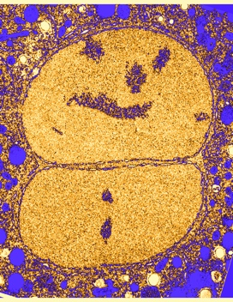
A fully funded post-doctoral position is available to study the mechanism of parental genome merging after fertilization, a process that is poorly understood, including in humans. Work in the model organism C. elegans suggests that this process requires pronuclear membrane junction formation, but whether an analogous process occurs in mammals is not known. The process will be examined in mice and will involve mouse embryo manipulations, mouse genetics and cutting-edge cell biology techniques, including fluorescence microscopy and 3D electron microscopy (FIB-SEM). This project will shed light on a fundamental cell and developmental biology question with implications for human fertility and embryonic development.

The position is part of a collaborative project between two NIH intramural labs headed by Drs. Carmen Williams at NIEHS in Research Triangle Park, North Carolina, and Orna Cohen-Fix at NIDDK in Bethesda, Maryland. The post-doctoral fellow will be based in the Williams lab and will have close interactions with both PIs and with trainees in the two labs. NIEHS is located in one of the biggest research parks in the US and is close to three outstanding universities: Duke, UNC at Chapel Hill and NC State. The fellow will spend time in the Cohen-Fix lab at the NIH campus in Maryland during the 3D electron microscopy parts of the project. Both labs have state-of-the-art facilities, and the environment is stimulating and highly collaborative. In addition, the fellow will have access to outstanding career development resources through the Office of Intramural Training and Education, including grant writing training, workshops on career options, networking opportunities, courses and more.

Candidates must:
• Be a PhD candidate or have a PhD degree in the biological sciences for less than 5 years.
• Have a strong publication record, including first author papers in peer reviewed journals.
• Have a strong background in cell biology and advanced imaging techniques. Experience with mouse embryos and/or electron microscopy is an advantage.
• Be highly motivated, creative and rigorous, have independent critical thinking ability in the design and interpretation of experiments, excellent command of the relevant scientific literature, and advanced written and oral communication skills in English.

To apply, please email ornac@niddk.nih.gov a single PDF file containing:
(1) A cover letter explaining why you are qualified for the position and why you are interested in this particular project, (2) Curriculum vitae, and (3) Names of three references with contact information (email and phone number). Applications will be evaluated as they are received until the position is filled. Informal inquiries are welcome, and additional information is available upon request.

We are dedicated to building a diverse community in our training and employment programs. Individuals from under-represented groups are strongly encouraged to apply.
NIH is an Equal Opportunity Employer.

